# Final Status Report

05/06/2020

Bubble Trouble (Carter, Abi, SK)

## Timeline

Week 1

----------

* Complete basic documentation: Master Story, Inception Deck, Timeline, etc.

* Create basic adjacency matrix from the input of name followed by preferences

* Complete 10 test cases

* Team Contributions: Carter 40%, Abi 30%, SK 30%

Week 2

----------

* Create release wall and storyboard

* Begin weighting pages with test outputs: after nth step each individual page's rank weight and page rank total

* Update basic documentation: Master Story, Inception Deck, Timeline, etc.

* Complete 10 more test cases

* Team Contributions: Carter 60%, Abi 20%, SK 20%

Week 3

----------

* Update release wall and storyboard

* Complete linear page rank

* Update basic documentation: Master Story, Inception Deck, Timeline, etc.

* Complete 10 more test cases

* Team Contributions: Carter 33%, Abi 33%, SK 33%

Week 4

----------

* Update release wall and storyboard

* Submit "A" Proposal

* Update basic documentation: Master Story, Inception Deck, Timeline, etc.

* Complete 10 more test cases

* Team Contributions: Carter 33%, Abi 33%, SK 33%

Week 5

----------

* Update release wall and storyboard

* Complete "A" Proposal

* Sort students into teams

* Update basic documentation: Master Story, Inception Deck, Timeline, etc.

* Complete 10 more test cases

* Team Contributions: Carter 33%, Abi 33%, SK 33%

## Tests By Week

Week 1

----------

|  |  |
| --- | --- |
| * TestZeroPreferences  * TestDiagonalZeros  * TestFailDiagonalZeros  * TestCorrectnessOfMatrix  * TestCorrectnessOfMatrix2 | * TestCorrectnessOfMatrixFail  * TestRange  * TestRange2  * TestUnpopularity |

Week 2

----------

|  |  |
| --- | --- |
| * TestFinalTotalPageRank1  * TestFinalTotalPageRank2  * TestFinalTotalPageRankLessThanOne1  * TestFinalTotalPageRankLessThanOne2  * TestFinalTotalPageRankLessThanOneFails | * TestFinalTotalPageRankFails  * TestFinalIndividualPageRank1  * TestFinalIndividualPageRank2  * TestFinalIndividualPageRank3  * TestFinalIndividualPageRankFails |

Week 3

----------

|  |  |
| --- | --- |
| * TestVerbose1  * TestVerbose2  * TestVerbose3  * TestVerbose4  * TestVerbose5  * TestVerboseFails1 | * TestNumNodesVsPeople1  * TestNumNodesVsPeople2  * TestNumNodesVsPeople3  * TestNumNodesVsPeople4  * TestNumNodesVsPeopleFails1  * TestNumNodesVsPeopleFails2 |

Week 4

----------

|  |  |
| --- | --- |
| * TestNumNodesVsPeopleFails3  * TestTeamSize1  * TestTeamSize2  * TestTeamSize3  * TestTeamSize4  * TestTeamSizeReduces1 | * TestTeamSizeReduces2  * TestTeamSizeExpands1  * TestTeamSizeExpands2  * TestTeamSizeFails1  * TestTeamSizeFails2 |

Week 5

----------

|  |  |
| --- | --- |
| * TestPolynomialPowerof1  * TestPolynomialPowerof3  * TestSequenceFibonacci  * TestSequenceRecaman  * TestSequencePasccal | * TestSequenceOverridePolynomial  * TestIndividualHappiness  * TestTeamHappiness  * TestTotalHappiness |

## Final Release Wall

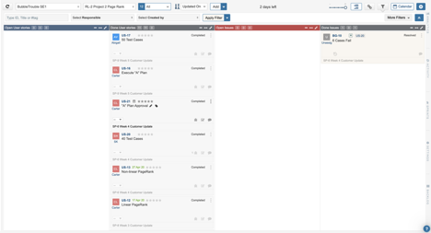

## Final Story Wall

